**NETAJI SUBHAS UNIVERSITY OF TECHNOLOGY**



**Student Information Management System**

**SEMESTER-3 (BATCH 2024-28) BRANCH- CSE**

SUBMITTED TO:

Mr. Anand Gupta

SUBMITTED BY:

Riddhi Khandelwal(2024UCS1503)

Anshita Singh(2024UCS1529)

Tanisha Gautam(2024UCS1536)

**Table of Contents**

| **S. No.** | **Section Title** |
| --- | --- |
| **1.** | Problem Statement |
| **2.** | Requirement Analysis |
| **3.** | Functional Requirements |
| **4.** | Non-Functional Requirements |
| **5.** | Scope of the Project |
| **6.** | Constraints |
| **7.** | Entities & Attributes |
| **8.** | Relationships Between Entities |
| **9.** | Functional Dependency |
| **10.** | Functional Dependencies for the Database |
| **11.** | Creating Tables Using Python |
| **12.** | Table Layout |
| **13.** | SQL Queries / Questions |
| **14.** | E-R Model |

**Problem Statement**

Managing student information in many educational institutions is still done through spreadsheets or manual record-keeping. As the number of students grows, these traditional methods become inefficient, error-prone, and difficult to maintain. Tasks such as tracking student details, managing course registrations, updating records, or generating reports become time-consuming and inconsistent.

To address these challenges, this project aims to design and implement a Student Management System using a Database Management System (DBMS). The system will provide a structured, centralized database for storing, updating, and easily retrieving student information, course details, and enrollment data. It will help reduce redundancy, maintain data accuracy, and simplify overall management for administrators and faculty members.

The goal is to build a database-driven solution that enhances efficiency, supports data integrity, and offers meaningful insights through various SQL queries and reports.

**Requirement Analysis**

**Functional Requirements**  
 A. Student Management  
 The system should allow adding new student records with details such as:  
 Student ID  
 Name  
 Date of Birth  
 Gender  
 Address  
 City/State  
 Contact information  
 Users should be able to update student details when required.  
 Admins should be able to delete student records.  
 The system should allow searching for students by name, ID, city, or other attributes.

B. Course / Subject Management  
 The system should maintain details of all courses/subjects including:  
 Course ID  
 Course Name  
  
 Users should be able to add, update, or remove course information.

C. Student Enrollment  
 The system must allow students to enroll in courses.  
 Each enrollment record must link a valid Student ID with a valid Course ID.  
 Enrollment must include details like:  
 Enrollment ID  
 Date of Enrollment  
 The system should prevent duplicate or invalid enrollments.

D. Reports / Queries  
 The system should support frequently needed queries such as:  
 List of students enrolled in a particular course.  
 Students grouped by city/state.  
 Total number of students in each course.  
 Filtered searches using conditions (e.g., students living in a certain state).  
 Displaying detailed information using JOIN operations.  
 Aggregate reports using COUNT, AVG, MAX, MIN, etc.

E. Database Setup  
 Provide SQL scripts to create tables (DDL).  
 Insert sample data (DML).  
 Include integrity constraints such as:  
 Primary Keys  
 Foreign Keys  
 Unique and NOT NULL constraints

**Non-Functional Requirements** A. Data Integrity  
 The database must avoid redundancy using proper normalization.  
 Foreign keys should ensure that data remains consistent and linked correctly.

B. Usability  
 The schema must be easy to understand and maintain.  
 Records should be simple to insert, update, and retrieve.

C. Performance  
 Queries should execute efficiently and return results promptly.  
 Indexing may be applied on frequently accessed fields.

D. Scalability  
 The database structure should allow adding future modules such as:  
 Attendance  
 Grades  
 Faculty Management  
 without major structural changes.

E. Portability  
 The SQL scripts should run on common relational database systems such as MySQL, PostgreSQL, or SQL Server with minimal changes.

**Scope of the Project**  
 The system focuses mainly on students, courses, and enrollment management.  
 It does not include deep ERP-level features (such as payroll or library management).  
 It is designed for academic purposes and can be extended later.

**Constraints**  
 The database assumes valid user input (e.g., correct formats for email or phone numbers).

**Entities & Attributes**

**Student**  
 student_id — Primary key (or unique identifier) for each student  
 first_name — Student’s first name  
 last_name — Student’s last name  
 gender — Gender of the student  
 dob — Date of birth  
 contact_no — Phone / contact number  
 email — Email address  
 address — Street / house address  
 city — City name  
 state — State name  
 zip_code — Zip or postal code  
 enrollment_date — Date when the student joined / was registered

**Course (or Subject)** course_id — Unique identifier for each course  
 course_name — Name/title of the course  
 duration — Duration of the course (could be in months / years / hours)  
 fee — Course fee (if maintained)

**Enrollment**  
 enrollment_id — Unique key for enrollment record  
 student_id — Foreign key referencing Student  
 course_id — Foreign key referencing Course  
 enroll_date — Date of enrollment  
 Relationships between Entitie

**Relationships between Entities**

Student ↔ Enrollment: One-to-many — A student can enroll in multiple courses.

Course ↔ Enrollment: One-to-many — A course can have many students enrolling.

Implied many-to-many relationship between Student and Course via the Enrollment table.

**Functional Dependency (FD)**

A Functional Dependency (FD) is a relationship between two sets of attributes in a database. It describes how one attribute uniquely determines another attribute. In simple terms: If the value of attribute A determines the value of attribute B, then B is functionally dependent on A.

A → B (Read as: “A functionally determines B”). For every value of A, there is only one corresponding value of B. Two rows that have the same value of A must have the same value of B.

**Importance of Functional Dependencies:** Functional dependencies help to remove redundancy, prevent update, insert, and delete anomalies, normalize database tables (1NF, 2NF, 3NF, BCNF), identify primary keys and candidate keys, and maintain data accuracy and integrity.

**Functional Dependencies for the Database** **1. STUDENT Table** Attributes: (id, rollno, sname, sem, gender, branch, email, number, address)  
 Functional Dependencies:

1. id → rollno, sname, sem, gender, branch, email, number, address
2. rollno → id, sname, sem, gender, branch, email, number, address

**2. ATTENDANCE Table** Attributes: (aid, rollno, attendance)  
 Functional Dependencies:

1. aid → rollno, attendance

**3. DEPARTMENT Table** Attributes: (cid, branch)  
 Functional Dependencies:

1. cid → branch
2. branch → cid

**Creating Tables using Python:-**

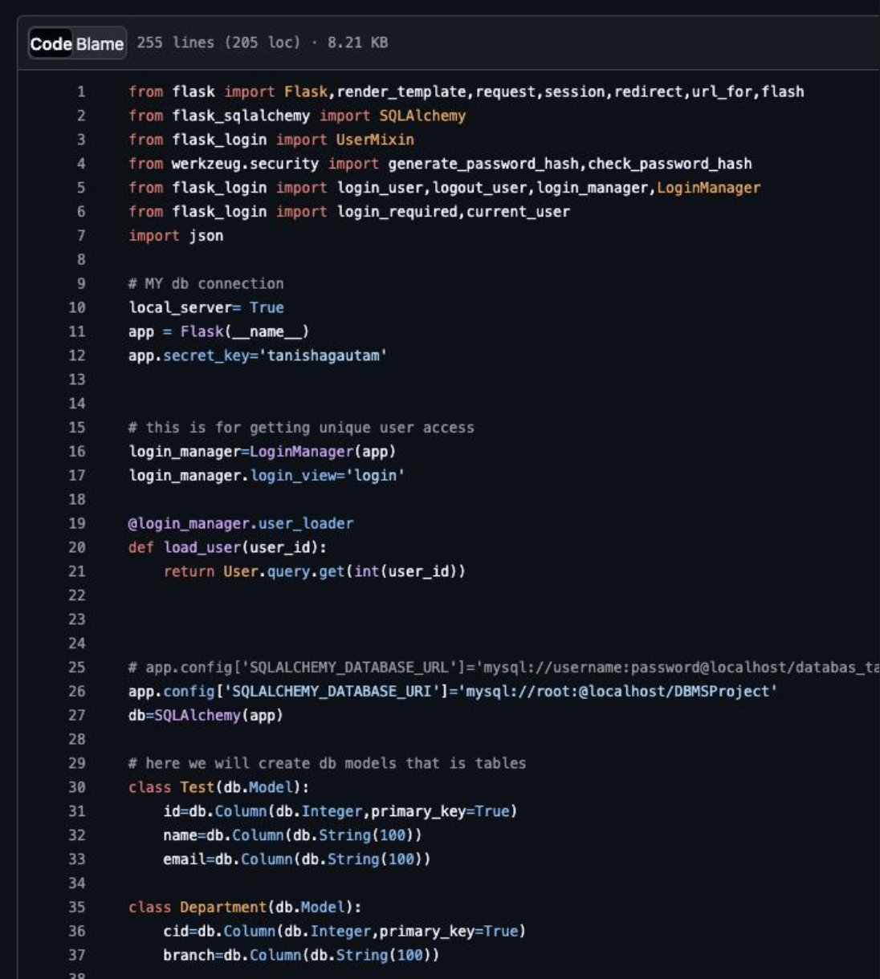

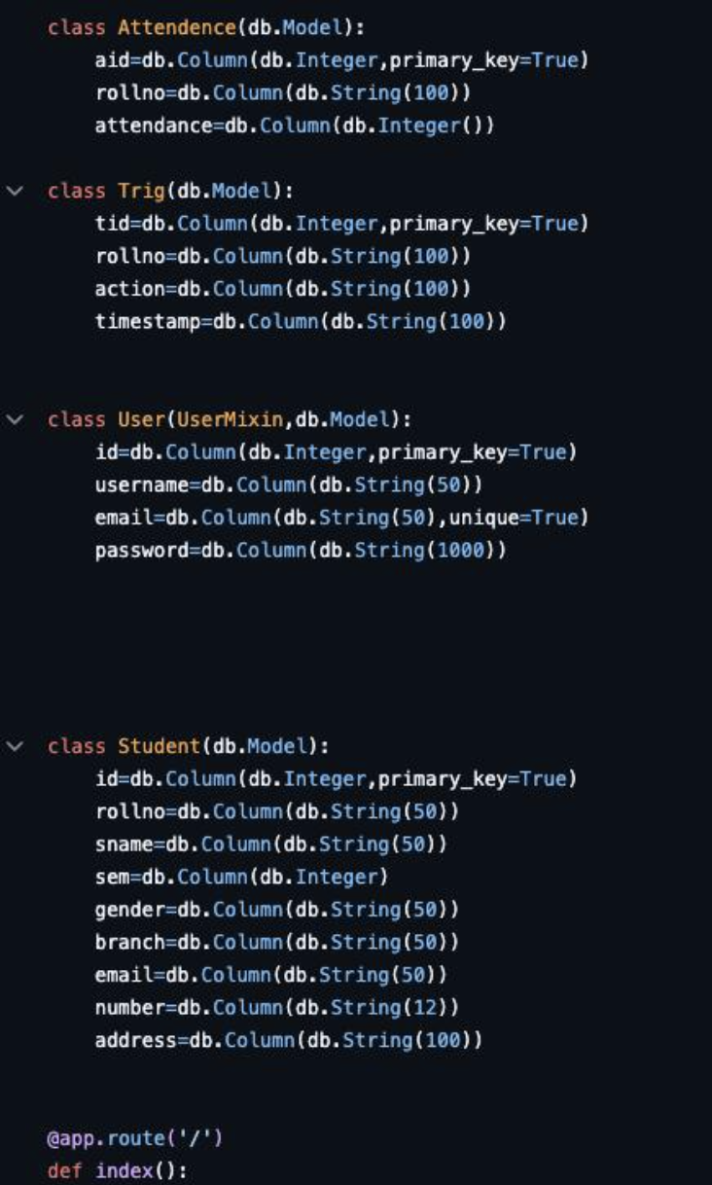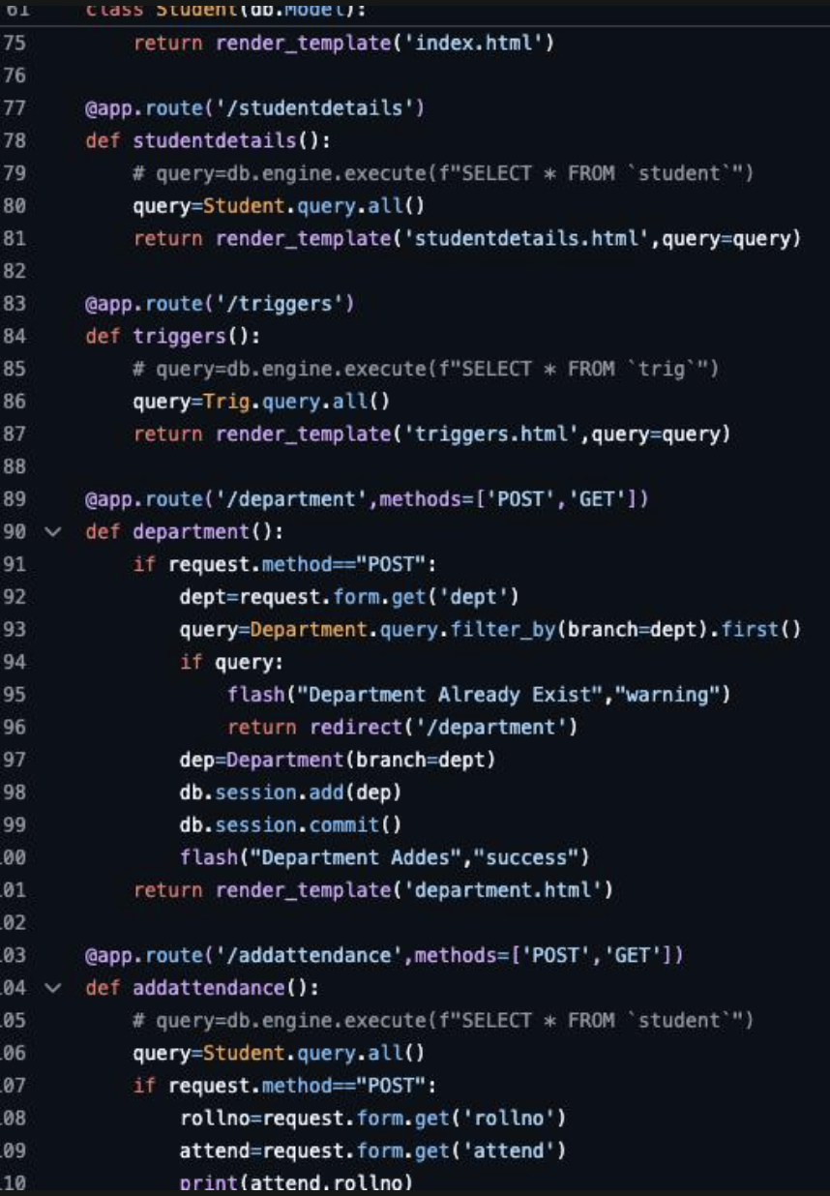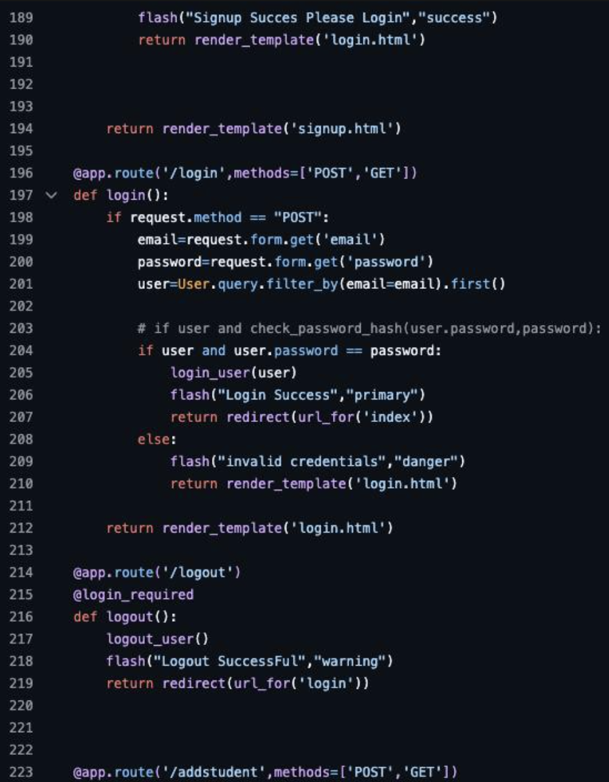

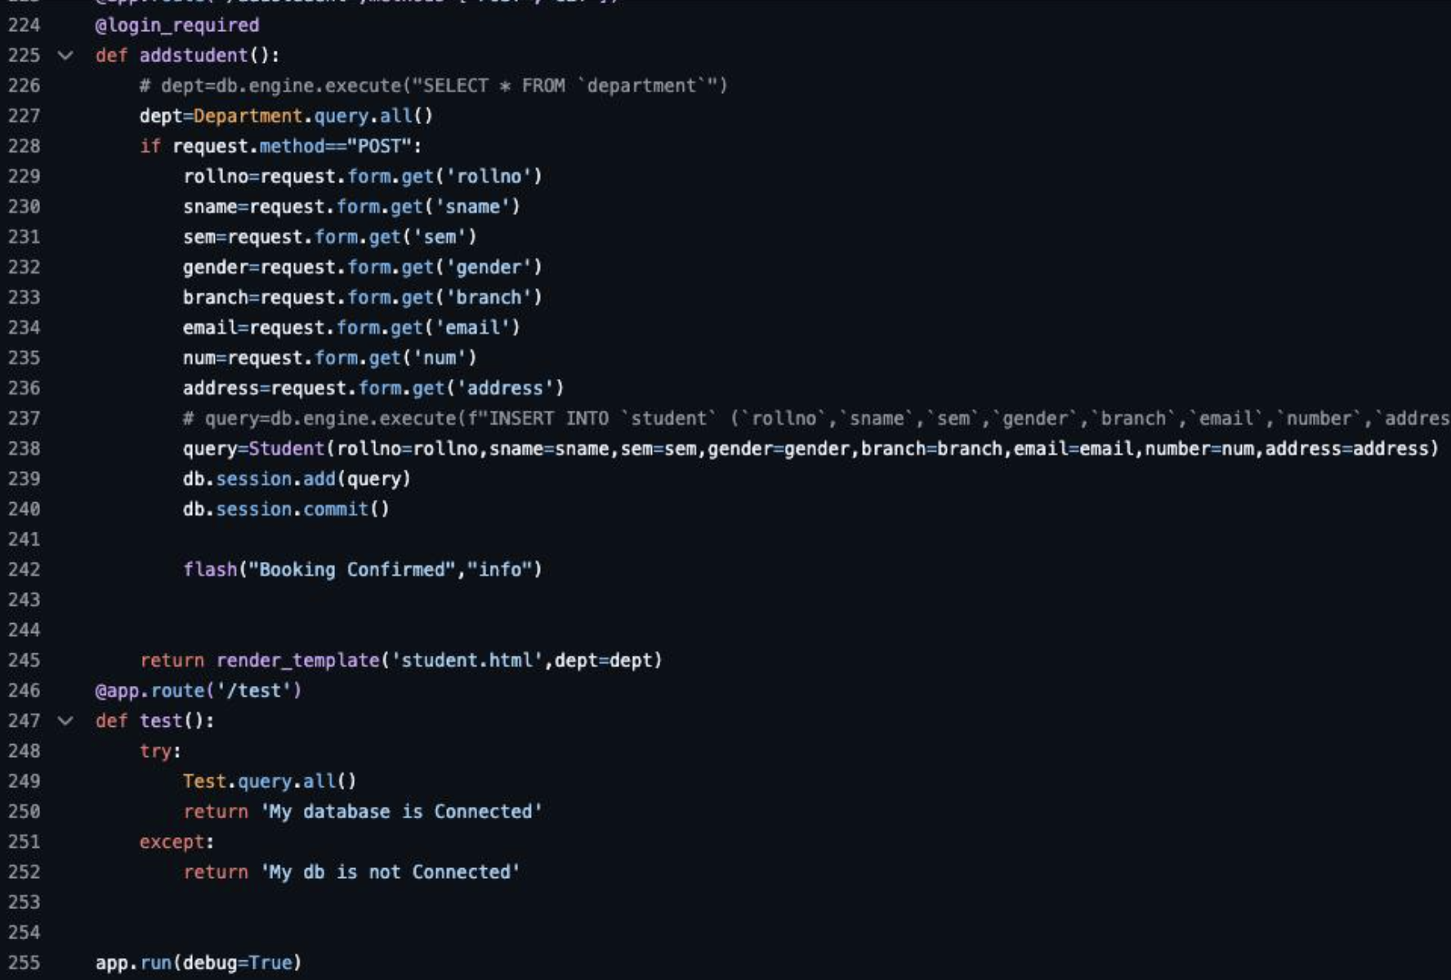

**Table Layout:-**

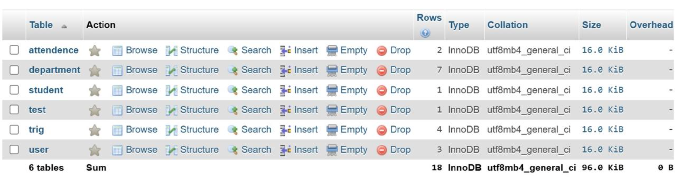

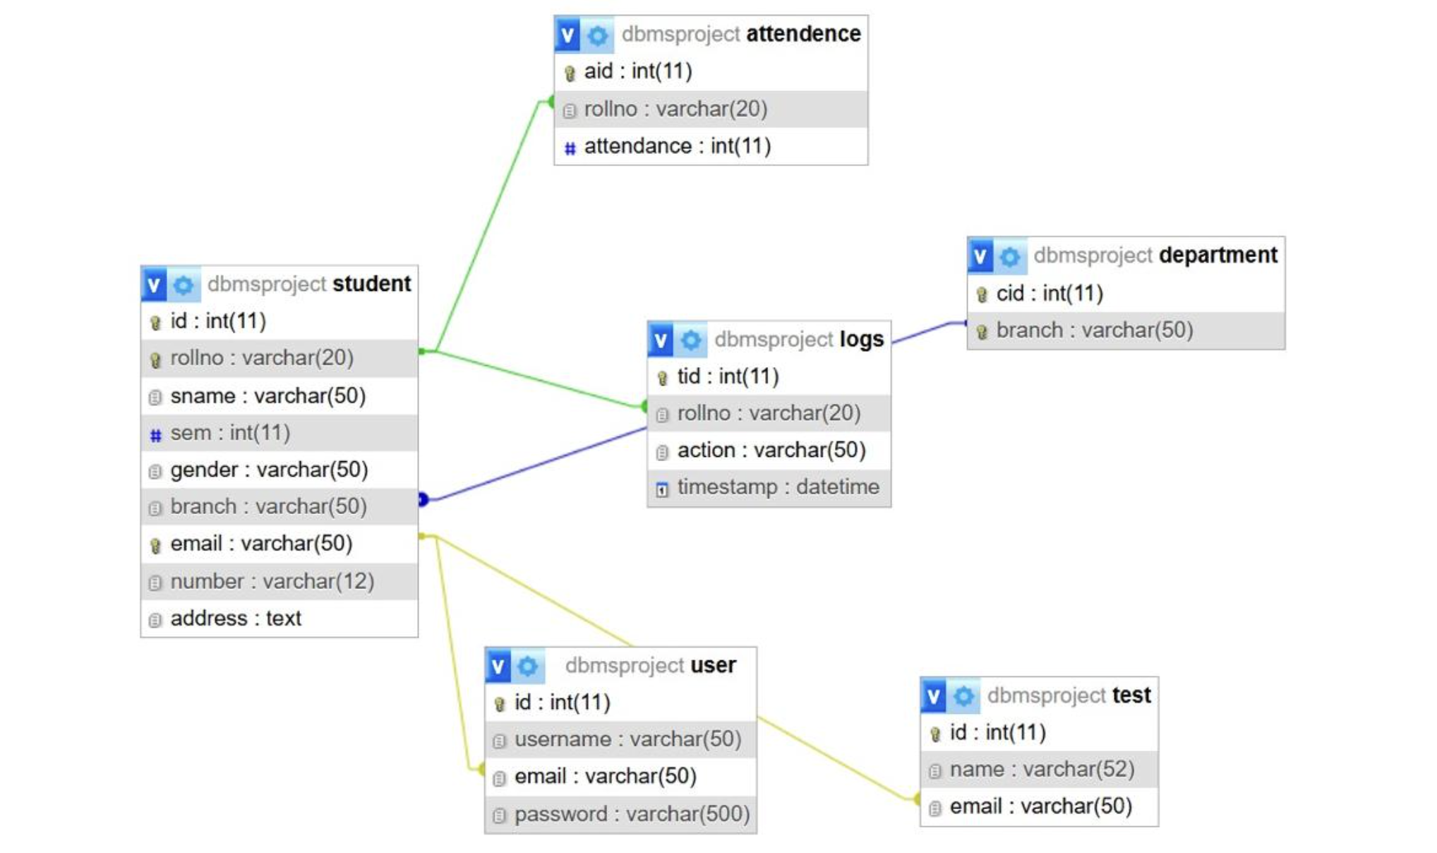

**SQL queries** 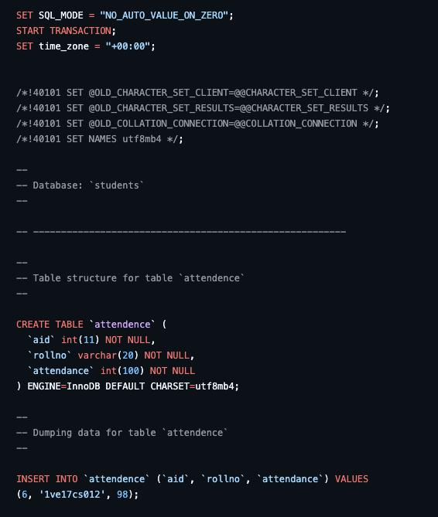

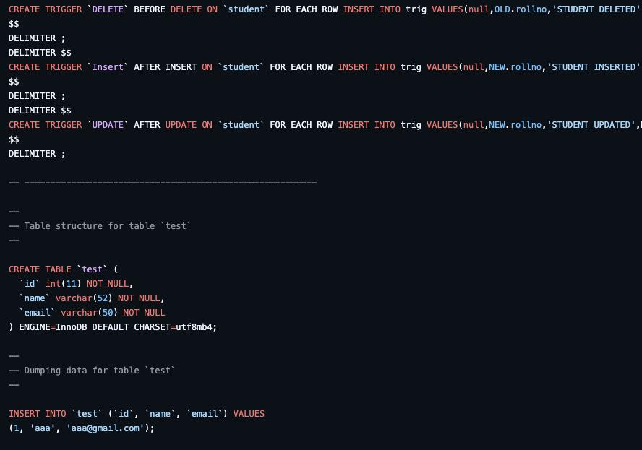

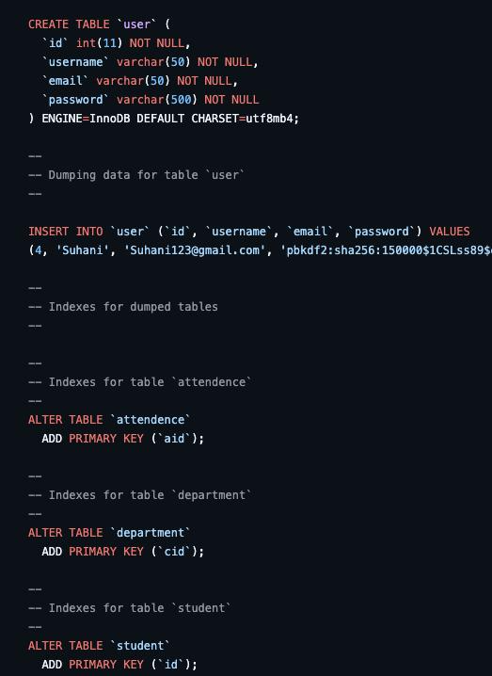

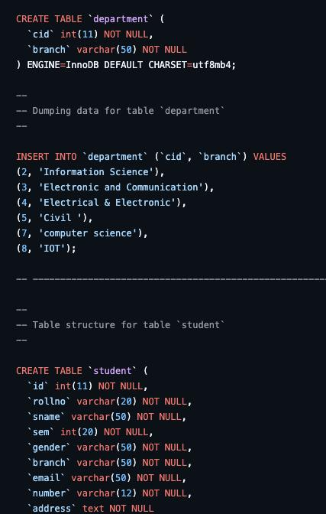

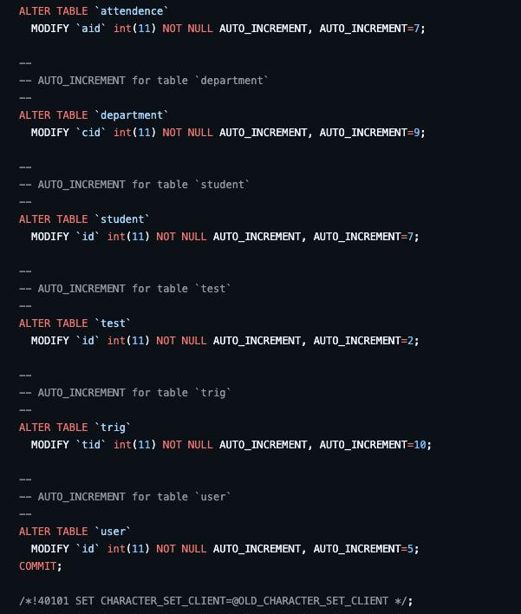

**E-R Model:-**

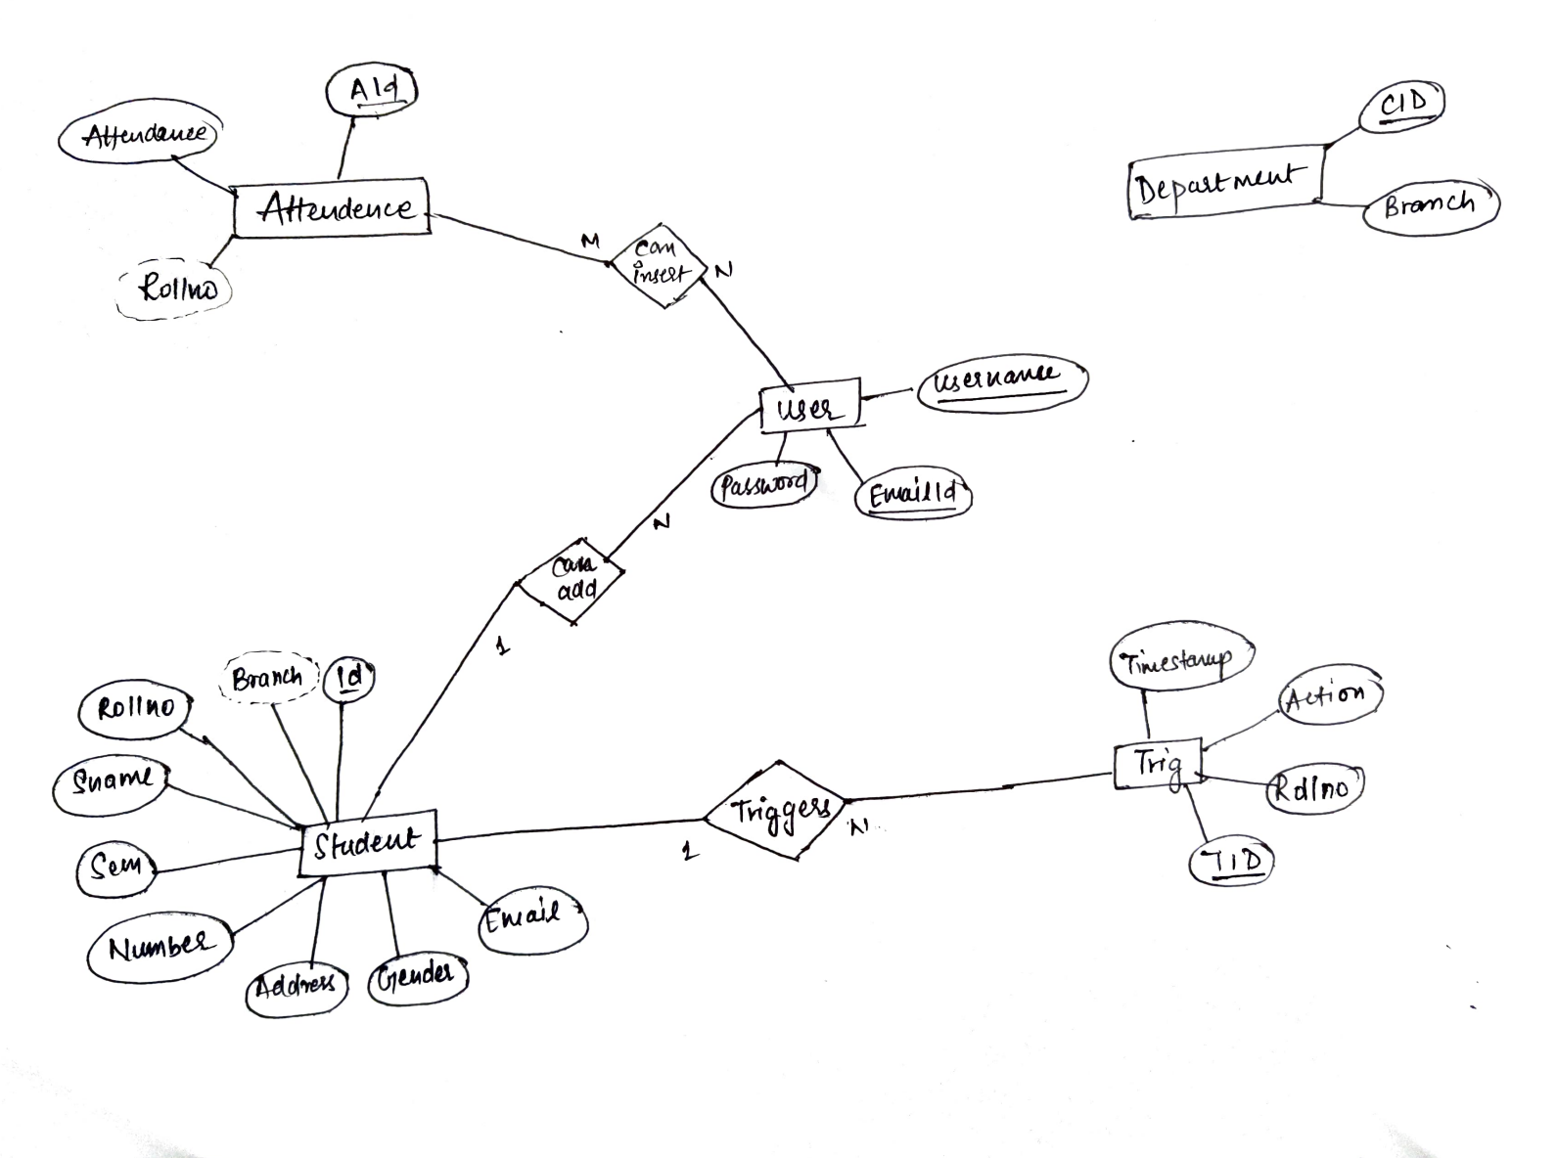

**Github link:-** [**https://github.com/leotanishaa/DBMS-Project/tree/main**](https://github.com/leotanishaa/DBMS-Project/tree/main)

**Final Project**

